Weather Unit Quiz Review
- Atmosphere
Name the layers going from the Earth and headed into space. Name one thing that is different about each layer.
  - Earth
  - Troposphere- Layer closest to the Earth, all weather occurs here
  - Stratosphere – Jet streams are found in this layer. Ozone layer found in this layer
  - Mesosphere – Coldest layer and meteors burn up in this layer
  - Thermosphere – Hottest layer and contains auroras
  - Exosphere – Outer most layer and satellites orbit in this layer
  - Space
- Wind

Land | Water
Heats up quickly  Cools off quickly  Warmer during the day | Heats up slowly  Cools off slowly  Warmer during the night
Global | Local
Created by direct and indirect light  Happens on a large scale  Occurs due to convection currents  - Heated by equator  - Cooled by the poles | Created by the unequal heating of land and water  Happens on a small scale

Warm Air | Cold Air
Less Dense  Rises  Less Pressure (Low Pressure) | More Dense  Sinks  More Pressure (High Pressure)  Moves towards warm air
Sea Breeze | Land Breeze
Happens during the day  - Land is warmer and has low pressure  - Water is cooler and has high pressure  Wind blows from sea to land | Happens at night  -Water is warmer and has low pressure  - Land is cooler and has high pressure  Wind blows from land to sea

Air Masses
- Air masses take their properties from _____the land or water that it forms over____
- A ___front____ is a boundary between two air masses.
# | Name | Properties
1 | mP | Cold and humid
2 | mT | Warm and humid
3 | cP | Cold and dry
4 | mT | Warm and humid
5 | mP | Cold and humid
6 | cT | Warm and dry
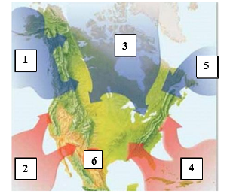
Fronts
Name | Drawing | Description | Weather
Warm Front |  | Warm air moves in to replace cold air | Light rain followed by warm clear weather
Cold Front |  | Cold air moves quickly under the less dense warm air | Thunderstorms, heavy rain or snow and then cool weather
Stationary Front |  | A cold air mass runs into a warm air mass. Neither has enough force to move the other out of the way | Several days of cloudy, rainy weather in one place
Occluded Front |  | A warm air mass is caught between two cold air masses. The two cold air masses move in and force the less dense warm air up | Bring cool temperatures and large amounts of rain and snow

