Mineral Properties Notes Key
# ________
How can I identify minerals? I can identify minerals by their properties.
How to test mineral properties
Property | Important facts | How to test this property
Color | - Easiest property to observe  - Only useful for a few minerals that are always the same color. | Look at the mineral and identify the color
Luster | - How a mineral reflects light  3 types of luster:  - Metallic (looks like metal)  - Submetallic (looks like dull metal)  - Non-Metallic (does not look like metal) | Look at the mineral under light and see how it reflects the light
Streak | - The color of a minerals powder  * The streak does not change even if the color of the mineral does.  Ex. Quartz can be many different colors but its streak is always white. | - Hold the mineral firmly and scratch the mineral on the streak plate.  - Record the color of the minerals powder that is left behind.
Cleavage  or  Fracture | - Mineral splits evenly along flat surfaces  ======================  - Mineral breaks apart in a jagged pattern | Observe the mineral.  Cleavage looks like smooth flat surfaces.  ========================  Fracture looks like ugly rough pieces
Hardness | - Mohs’ hardness scale ranks minerals from 1 to 10 in order of hardness (Talc is softest, Diamond is hardest)  - A mineral can scratch any mineral softer than itself | 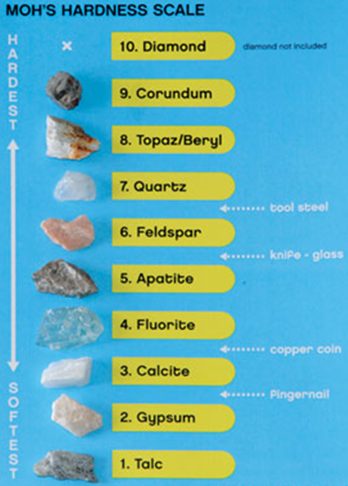
Density | - The measure of how much mass is in a given amount of space.  - always the same for each mineral | - Find the mass on a scale.  - Find the volume using graduated cylinder.  - Use the formula below to calculate the density.
Other  Special  Properties | - Fluorescence – glows in the dark  - Magnetic  - Chemical reactions  - Taste  - Smell

