Weather Unit Quiz Review
- Atmosphere
Name the layers going from the Earth and headed into space. Name one thing that is different about each layer.
  - Earth
  - _____________________________________________________________________________________
  - _____________________________________________________________________________________
  - _____________________________________________________________________________________
  - _____________________________________________________________________________________
  - _____________________________________________________________________________________
  - Space
- Wind
Local | Global

Land | Water

Sea Breeze | Land Breeze
Air Masses
- Air masses take their properties from _________________________________________________________
- A __________________ is a boundary between two air masses.
# | Name | Properties
1
2
3
4
5
6
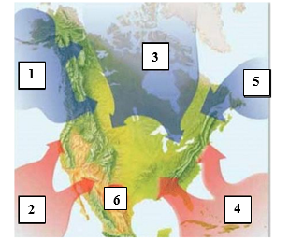
Fronts
Name | Drawing | Description | Weather
Warm Front
Cold Front
Stationary Front
Occluded Front

