Name ___________________________________ Water on Earth Study Guide

- Draw and label the parts of the water cycle. Include transpiration, infiltration, and surface runoff. Be able to describe how water moves through the water cycle.
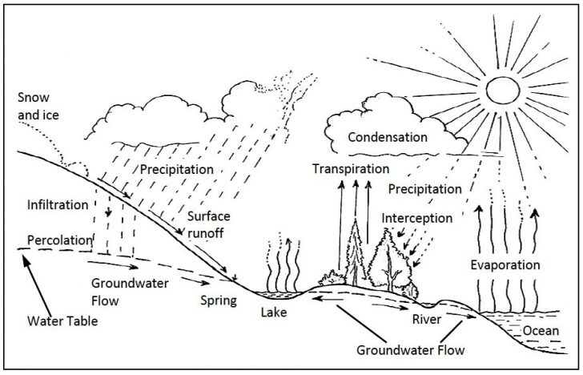

2. The percentage of the Earth covered in water is _71% (rounded to 70%)_ and the part covered by land is 29% (rounded to 30%).

3. _97_% of the Earth’s water is salt water and _3%_ % of the Earth’s water is freshwater. Why is most freshwater unusable? _Most freshwater is frozen__

4. Why is the ocean salty and lakes and rivers are not? Dissolved minerals from surface runoff are carried into to the ocean. Water is continuously evaporating out of the ocean leaving the salts behind.

5. What is an aquifer? A body of rock or sediment that contains ground water that allows it to flow._

6. Complete with names of features found on the ocean floor:

- _Seamount_: a volcano or mountain that does not rise above the surface of the ocean
- __Abyssal Plain___: a flat almost level area of the ocean floor
- _Continental Shelf____: part of the continent that is covered by sea water from land to the continental slope
- _Ocean Trench___: a deep valley in the ocean
- _Mid-ocean ridge__: underwater mountain chain
- _volcanic island___: when a seamount rises above sea-level
- __continental slope__: steeply sloping edge of the continental shelf that drops to the ocean basin

7. A large stream of moving water that flows through the oceans is called a __current__.

8. What are the three causes of currents? Wind, differences in temperature causing changes in density and differences in salinity that cause changes in density.

9. The largest and most powerful surface current in the North Atlantic is called the

__Gulf Stream__. How does it affect climate in Europe?__The warm surface current warms up the climate.

10. What causes ocean currents to curve to the right in the Northern Hemisphere?
The Coriolis Effect – the rotation of the Earth

11. Compare surface currents and deep ocean currents:

Surface Currents Deep Ocean Currents
- Only at the surface  - Created by wind  - Warm surface currents are near the equator  - Cold surface currents are near the poles | - On the surface and deep in the ocean  - Created by density differences  - “conveyer belt’ of the ocean  - takes around 1,000 years to complete

12. What are tides? What causes them?
The daily rise and fall of Earth’s waters at its coast lines that are caused by the gravitational pull of the moon and the rotation of Earth.

13. What is a wave?
The rhythmic disturbance that carries energy through matter (the matter in our case is water)

14. What three things can affect the size of a wave?
The length of time the wind blows, the strength of the wind, and the distance the wind blows.

15. Draw and label the features of the ocean floor. Include seamount, continental shelf, continental rise, abyssal plain, mid-ocean ridge, volcanic island, trench, and continental slope.

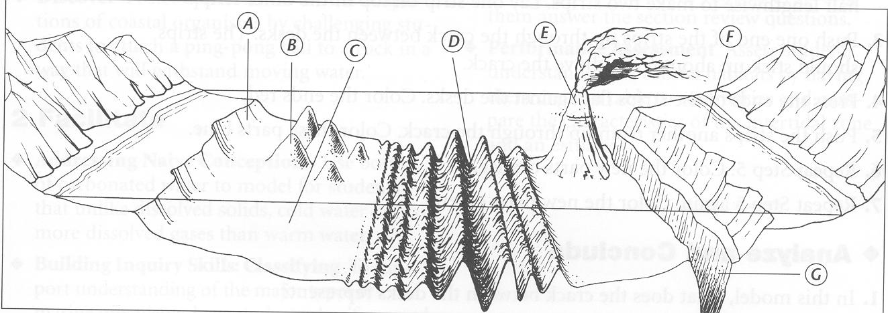

A – Continental Slope
B – Sea Mounts
C – Abyssal Plain
D - Mid Ocean Ridge
E – Volcanic Island
F – Continental Self
G – Trenches
H – Continental Rise

