Waves, Currents, and Tides!
Waves!
- A wave is a ___rhythmic___ movement that carries __energy___ through matter
and space. In the ocean waves move through ___mattere___.
- When _wind__ blows across a body of water, energy is _transfered__ to the water.
- When the wind speed is great enough water begins to pile up, forming a _wave__.
- Waves continue to moving for long distances even if the wind __stops blowing
Ocean Currents!
- Ocean currents are a ____mass flow of ocean water.
- There are two main types of currents:
  - Surface Currents
  - Deep Ocean Currents
Surface Currents
- Surface currents move water ____horizontally__ and __parallel_ to the Earth’s surface.
- Surface Currents are powered by wind.
- There are _____Warm____ and ______Cold______ surface currents.
- Surface winds and surface currents are affected by the rotation of the Earth.
  - This is called the Coriolis Effect.
Deep Ocean Currents
- Deep ocean currents circulate because of ____density___ differences.
- ______More_ dense seawater sinks beneath less dense seawater.
How it works!
When water becomes colder it becomes more dense, causing it to sink. It flows along the ocean floor until it hits warmer regions and the water heats up. When the water heats up it becomes less dense and floats. It flows along the ocean surface until it hits colder regions and it cools off.

Tides!
- Tides are the daily __rise_____ and __fall__ of Earth’s water.
- As the tide comes in, the level of water on the beach __goes up, and as the tide goes out, the level of water on the beach goes down.
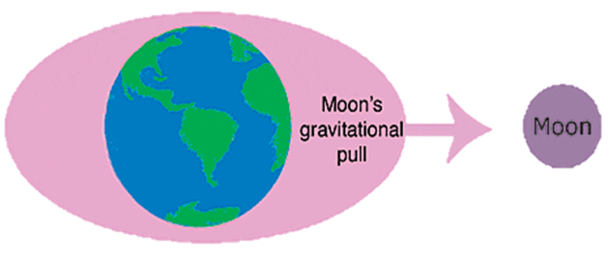
- The gravitational pull from the _moon___ , and the rotation of the ___Earth__ on its axis, cause the ocean and sea water to bulge, producing the __tides___.
- The Moon pulls on the water on the side ____closest_ to it more strongly than it pulls on the center of the Earth. This pull creates a bulge of water on the side of Earth ___nearest__ the Moon.
- At times, the Sun and Moon pull together on Earth’s waters in the ____Same direction (spring tide)___.
- At other times they pull in _opposite directions (neap tide).

