Unit 5 Study Guide
Layer of the Earth | State of Matter  (Solid, Liquid, or Gas) | Composition  (What is it made of) | Thickness | Special Features
Crust | Solid | Oxygen, silicon, aluminum, Granite | 5 – 100 km | - All life exists here  - Tectonic plates  - Oceanic and Continental Crust
Mantle | Solid that acts like a liquid | Iron and Magnesium | 100 km – 3,000 km | - Largest Layer  - Three sections
Outer Core | Liquid | Iron and Nickel | 3,000 – 5,200 km | Liquid
Inner Core | Solid | Iron and Nickel | 5,200 km – 6,428 km | Solid  Most dense  Hottest

- What three things increase as you move from the crust to the inner core?
__Density__ ___Temperature__ ___Pressure__
- What are the layers of the Earth in order (including the ‘spheres’)?
- __crust__ 2. __Mantle__ 3. ___Lithosphere__ 4. __asthenosphere__ 5. __mesosphere_ 6.___Outer core___ 7. __Inner Core__
- Explain what convection currents are including why it happens.
_Convection currents are the driving force for plate tectonics. They occur in the mantle and they occur because when you heat up they become less dense and rise and when the cool off they become more dense and they sink__.

- Sea floor spreading happens at the ___mid-ocean ridge_______.
- Explain Continental Drift
__The continents were once all connected in a super continent called Pangea. Convection currents are causing the lithospheric plates to move._
- Where do most earthquakes and volcanoes form? Along the edges of tectonic plates, more specifically The Ring of Fire
- Explain sea floor spreading
__The process by which new oceanic lithosphere forms as magma rises to the Earth’s surface and solidifies at the mid-ocean ridge_.

- The person responsible for the continental drift theory is __Alfred Wagner_ and he used the following pieces of evidence to support his theory:
  - _Jigsaw_ b.__Geographical Oddities__ c. ___Fossil Evidence__ d. geologic rock structures
- The person responsible for the continental drift theory is __Harry Hess_ and he used the following pieces of evidence to support his theory:
  - _molten material_ b.__age of rocks___ c. __magnetic stripes__
- The continents were once one single land mass or super continent called __Pangea__.
 | Describe the Movement of Both Plates and What Occurs When They Interact | What feature is created?
Convergent Boundary  Continental - Continental | The continental plates are running into each other and are folding up on each other. | Mountains
Convergent Boundary  Continental - Oceanic | The oceanic and continental plates are running into each other. The more dense oceanic crust subducts under the less dense continental crust | Volcanoes
Divergent Boundary  Oceanic - Oceanic | Two oceanic crusts are separating. This specific divergent boundary is called a mid-ocean ridge. This is the location or sea floor spreading | New oceanic crust  Mid-ocean ridge
Transverse Boundary  Continental - Continental | Two continental crusts are sliding past each other. | Earthquakes  Faults
9. Explain how fossils could be used as evidence to support continental drift. Fossils can be used to tell what the climate was like in that area in the past. This climate may be different than the current climate, showing that the continent moved closer or further from the equator. Fossils also line up in bands when Pangea is re-connected.

10. Continental crust is _less__ dense than oceanic crust. This is why _oceanic__
crust subducts under _continental_ crust.
11. The Ring of Fire is an area where a large number of ___volcanoes_ and __earthquakes_ are found. Explain why this is. The Ring of Fire is the direct result of plate tectonics and the movements and collisions of tectonic plates
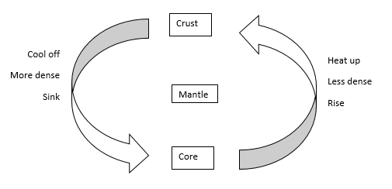
12. Draw a convection current and label it with less dense, more dense, rise, sink, core, crust, mantle, heat up, and cool off.

