Space Study Guide!
- What is a revolution? Does it represent a day or a year?
____________________________________________________________________________________________________________________________________________________________

- What is a rotation? Does it represent a day or a year?
______________________________________________________________________________
______________________________________________________________________________
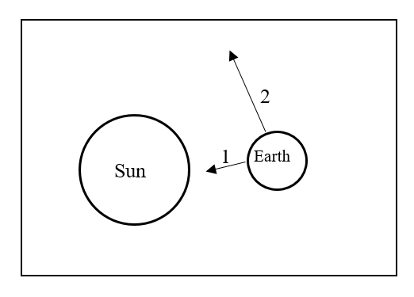
- What does arrow one represent?
______________________________
What does arrow two represent?
________________________________

- What are the two factors that affect gravity and how do they affect gravity?
  - ________________________________________________________________________
  - ________________________________________________________________________
- Inertia states that an object:
  - At rest will _______________________________________________________________
  - In motion will stay ________________________________________________________
  - In motion will stay ________________________________________________________
- The revolution of Earth will cause constellations to _____________________________________
______________________________________________________________________________
- The rotation of Earth will cause constellations to ______________________________________
______________________________________________________________________________
- What do all terrestrial planets have in common?
  - _________________________________
  - _________________________________
  - __________________________________
- What are the four terrestrial planets in order starting at the sun?
1. ____________________________________
2. ____________________________________
3. ____________________________________
4. ____________________________________
Earth  - Earth is the ________ planet from the sun.  - Earth contains the most __________ ______________________________  - Earth’s diameter ______________  - Earth’s density ________________  - Earth’s Gravity ________________ | Mars  - Mars is the ___________ planet from the sun.  - What makes Mars red in color?  ______________________________  - The largest mountain and volcano in the  solar system is called _______________  _________________________________
Venus  - Venus is the _______ planet from the sun.  - Venus is called Earths __________  - What does venus have in common with Earth?  ______________________  ______________________  ______________________ | Mercury  - Mercury is the _______ planet from the sun.  - Mercury is the _____________ planet.  - The surface of Mercury looks a lot  like the ________________.

