Space Motion and Inner Planets
Space Movements
- Orbiting or Revolving
  - When a celestial object or space craft moves in a curved path around another celestial object.
  - Example: ____the moon orbits the Earth____________________
- Rotation
  - The act of ___rotating_____ or _____spinning_____ around an axis or center.
  - Example: _____the earth rotates on its axis _______________
- Gravity
  - The force that attracts an object ___towards____ another object with a __mass__
  - Gravity depends on two factors: ___mass____ and ___distance__
    - The ___larger___ the ___mass___ the stronger the gravity.
    - The ___smaller___ the ___distance_____ the stronger the gravity.
- Inertia
  - A property of matter that states that an object will ___continue_ doing whatever
___motion___ it is currently doing unless __acted on___ by another force.
    - An object that is not moving will continue ____not moving_____.
    - An object that is moving will continue ____moving___ at the __same___ rate.
    - An object moving will continue moving in a ______straight line______.
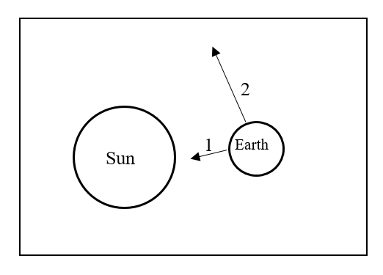
- How Do Objects Move In Space?
  - Gravity pulls objects towards the __sun__.
  - Inertia keeps the object __revolving_ in space.
- Observing Motions in Space
  - Constellations and the Sun _rise__ and __set____ on different sides of the planet
due to the ____rotation_ of Earth.
  - Constellations and Stars seem to ___appear__ and __disappear___ in the
night sky at different times in the __year___ due to the Earth moving in is
__orbit__ around the ___Sun__.
- The Planets In Order from the Sun are:
- ____Mercury__ 2. ___Venus___ 3. ___Earth____4. ___Mars_____
5. ____Jupiter___ 6. __Saturn____ 7. ___Uranus___ 8. ____Neptune____
- Terrestrial Planets
  - Terrestrial planets are four _inner_, ____rocky____, __dense__ planets that orbit closest to the ___Sun__.
- Mercury
Distance From the Sun | Length of Day | Length of Year | Tilt of Axis | Diameter | Density | Surface Temperature | Surface Gravity | Number of Satellites
0.39 AU | 58d 15.5h | 88 days | 0 | 4,879km | 5.44g/cm3 | -184C to 427C | 38% | 0
- Mercury’s surface is heavily __cratered__ and can be described as __Moon like____.
- Mercury has the most extreme temperature changes in the solar system.
  - During the day the temperature is _427C__ At night the temperature is -184C____
  - Mercury is the __first__ planet in the solar system.
- Venus
Distance From the Sun | Length of Day | Length of Year | Tilt of Axis | Diameter | Density | Surface Temperature | Surface Gravity | Number of Satellites
0.72 AU | 243 d | 225 d | 177.4 | 12,104km | 5.20gm/cm3 | 465c | 89% | 0
- Venus is often called __Earths twin_______
- The three things Venus has in common with Earth are
  - Diameter, mass, gravity___
- Venus is different in Earth in the direct is rotates.
  - Venus rotates in a ____retrograde_________ motion.
- There are __168__ volcanoes on Venus.
- Earth
Distance From the Sun | Length of Day | Length of Year | Tilt of Axis | Diameter | Density | Surface Temperature | Surface Gravity | Number of Satellites
1.0 AU | 23h56m | 365.3d | 23.45 | 12,756km | 5.52g/cm3 | -89c to 58c | 100% | 1
- Life as we know it needs ___water___ and ___energy_________
- Earth is unique in the fact that it has liquid ___water___
- Earth is ___geologically___ Active
  - It has __tectonic___ plates that move around Earth’s surface causing continents to change position over long periods of time.
- Between 1969 and 1972 _12___ astronauts have landed on the Moon.
- Mars
Distance From the Sun | Length of Day | Length of Year | Tilt of Axis | Diameter | Density | Surface Temperature | Surface Gravity | Number of Satellites
1.52 AU | 24h 37m | 1.88y | 25.3 | 6,792km | 3.93g/cm3 | -140c to 20c | 37% | 2
- Mars has an atmosphere that is __100_ times thinner than Earth.
- The chemical breakdown of the iron rich rocks called iron oxide that cover Mars’ surface gives Mars a _orange-red__ color.
- Mars contains the largest mountain and volcano in the solar system and it is called ___Olympus Mons____

