Unit 1 Study Guide Name _________________________________________ Period __________
- Describe the difference in the geocentric theory and heliocentric theory of the solar system.
Geocentric theory | Heliocentric theory

- The theory that scientists use to explain the formation of the universe is known as

___________________________________________.
- Label the diagram to show the correct relationship between the universe, earth, and galaxy:

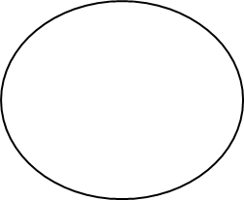

- Where is our solar system located in the Milky Way Galaxy? ___________________________________

- Compare the planets:
Inner planets | Outer planets

- Compare and contrast these space objects:
Comets | Meteors | Asteroids
- Label the model of our solar system:

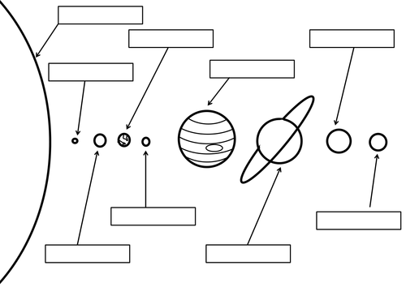

- Why do stars and constellations appear to move across the sky? ___________________________________________________________________________________
- Describe the difference between gravity and inertia in movement of objects in space:

___________________________________________________________________________________

____________________________________________________________________________________

- Identify the object in our solar system based on the characteristics:
Characteristic | Object
Rust-colored surface
Earth’s twin
Great Red Spot
Lots of liquid water
Lots of rings made of ice
Tilted 90 degrees
Dwarf planet
Smallest planet
Planet farthest from the sun
Located between the inner planets and outer planets
The center of our solar system

