Picture  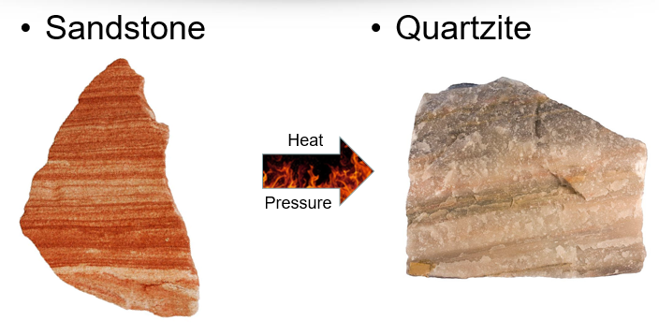 | Explanation  Metamorphic Rocks are formed from sedimentary rocks, igneous rocks, or other metamorphic rocks that have been changed by HEAT or PRESSURE. | Explanation  Texture is the position of the grains | Picture  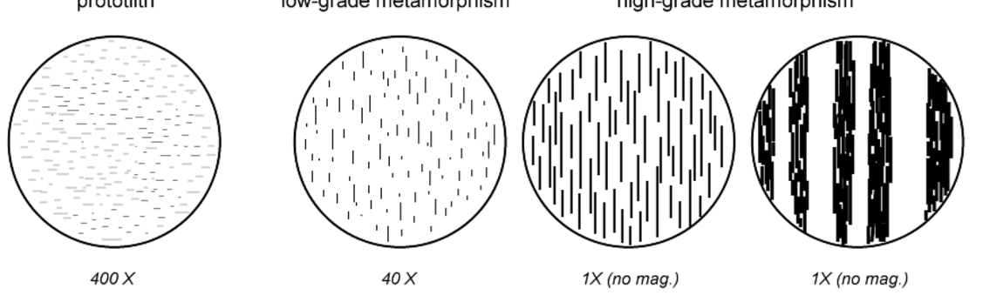
 | How they are formed  Metamorphic rocks are formed under ground by heat and/or pressure | Mineral grains are arranged in bands or layers. | 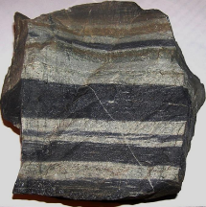
 | Composition is what the rock is made of.  Composition helps us determine how and where the rock was formed. | Mineral grains are not arranged in bands or layers. | 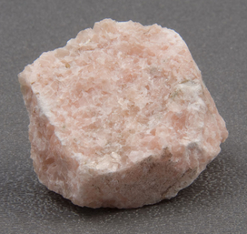
Composition |  |  | Non-Foliated
Origin |  |  | Foliated
Metamorphic  Rock |  |  | Texture

