Name _____________________________________________________________ Period __________
Atmosphere and Wind Notes
- The Earth’s atmosphere is made up of ___5 different layers and a mixture of different gasses___.
- The atmosphere is not _uniform____( or the same all the way through).
  - It’s __properties__ change with ___altitude___.
- The two properties that change are
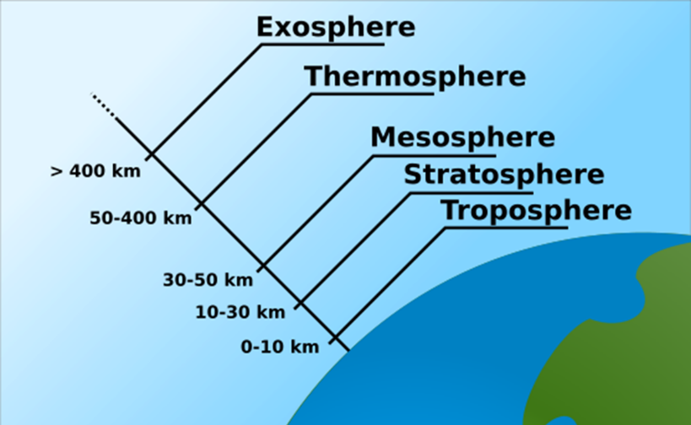
  - ___temperature__ and __pressure___
Layers of the Earth from Earth to Space
- Troposphere
  - This is the ____layer closest to the Earth’s surface__
  - _0_km to _16 km
  - All weather happens in the troposphere.
  - Temperature _drops_ as altitude increases.
- Stratosphere
  - _16_ km to __50_ km
  - Temperature _increases_ with altitude
  - Protective _ozone layer_ is at the top of the stratosphere.
  - _jet streams_ are found in this layer.
- Mesosphere
  - Extends from __50__km to __90__km.
  - Temperature drops _ with altitude.
  - _Coldest_ layer of the atmosphere.
  - Meteors burn up in this layer.
- Thermosphere
  - Extends from _90_ km to _300_ km
  - Temperature _increases_ with altitude
  - _Hottest_ layer of the atmosphere.
  - Curtains of light called __auroras __ occur in this layer.
- Exosphere
  - The outermost layer of the atmosphere.
  - Temperature goes __down_ with altitude.
  - _Satellites__ orbit the earth in the exosphere.
Wind Notes
- Cold air is more __dense___ than warm air.
- Air that is ___heated__ rises.
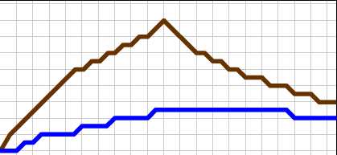
Land Vs Water
- Land heats up ____faster____ than water.
- Land cools off _____faster___ than water.
- Water heats up ___slower____ but _holds on to__ heat better than land.

Wind
- The movement of air caused by differences in ___air pressure____ is wind.
- Areas of _High_ pressure will always move towards areas of _Low pressure.
- The greater the differences in __air pressure__ the __stronger__ the wind moves.
- Air _rises at the equator and __sinks_ at the poles.
- The Coriolis Effect causes the wind to __curve__.
Global Winds
- Global winds are created by __unequal heating__ of Earth’s surface.
  - direct sunlight
  - _indirect_sunlight
- Global winds blow _steadily_ from specific directions over __long_ distances.
- Global convection currents are caused by the differences in direct and indirect light.
Local Winds
- Local winds blow over _short distances
- They are caused by _unequal_ heating within small areas; near mountains or water.
- Two specific local winds we will talk about :
Sea Breeze  - When wind blows from the _sea___ towards the __land__.  - This happens in the _day_ when __land_ is warmer than the _water__.  Land  Warm Air  Low Pressure  Water  Cool Air  High Pressure  Wind | Land Breeze  - When wind blows from the _land_ towards the _sea_.  - This happens at _night_ when the _land_ cools more quickly than the __water__.  Land  Cool Air  High Pressure  Water  Warm Air  Low Pressure  Wind

