Unit 1 Study Guide Name _________________________________________ Period __________
- Describe the difference in the geocentric theory and heliocentric theory of the solar system.
Earth is in the center  Earth  Geocentric theory | The sun is in the center  Earth  Heliocentric theory

- The theory that scientists use to explain the formation of the universe is known as
The big bag theory
- Label the diagram to show the correct relationship between the universe, earth, solar system and galaxy:
Universe
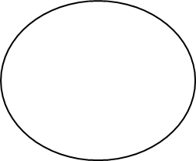
Earth
Solar System
Galaxy

- Where is our solar system located in the Milky Way Galaxy? _____outer rim or arm_____

- Compare the planets:
Inner planets | Outer planets
Less dense  Smaller  Less moons  No rings  Mercury  Venus  Earth  Mars | More dense  Larger  More moons  Has rings  Jupiter  Saturn  Uranus  Neptune

- Compare and contrast these space objects:
Comets | Meteors | Asteroids
Made of frozen gas and dust | Made of dust and rock and can enter the Earth’s atmosphere and burn up. | 1 – 1000 km in diameter  Made of iron and nickel  Has no atmosphere.
- Label the model of our solar system:

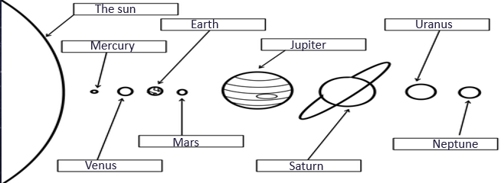

- Why do stars and constellations appear to move across the sky?
They change their location due to the revolution of Earth. They rise and set due to the rotation of the Earth.
- Describe the difference between gravity and inertia in movement of objects in space:
Gravity pulls Earth towards the sun. (1) Inertia keeps Earth revolving in space. (2)
- Identify the object in our solar system based on the characteristics:
Characteristic | Object
Rust-colored surface | Mars
Earth’s twin | Venus
Great Red Spot | Jupiter
Lots of liquid water | Earth
Lots of rings made of ice | Saturn
Tilted 90 degrees | Uranus
Dwarf planet | Pluto
Smallest planet | Mercury
Planet farthest from the sun | Neptune
Located between the inner planets and outer planets | Asteroid Belt
The center of our solar system | Sun

