Unit 3 Review Worksheet
Circle the correct answer in the table below
Type | Where it forms | Temperature | Humidity
Continental Polar | Over ocean Over land | Warm Cold | Moist Dry
Continental Tropical | Over ocean Over land | Warm Cold | Moist Dry
Maritime Polar | Over ocean Over land | Warm Cold | Moist Dry
Maritime Tropical | Over ocean Over land | Warm Cold | Moist Dry

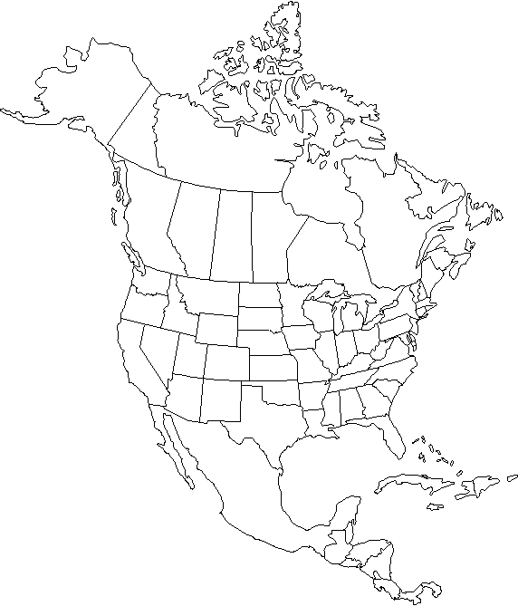
Complete the table below using the image on the right.
E
D
C
B
A
Letter | Temperature  (Cold, Warm) | Humidity  (Dry, Humid) | Name of Air Mass (CT,CP,MT,MP)
A | Warm | Humid | MT
B | Warm | Dry | CT
C | Cold | Dry | CP
D | Cold | Humid | MP
E | Warm | Dry | CT
Complete the chart about warm and cool air.
 | Warm Air | Cool Air
Which Direction Does it Move? | rises | sinks
Does it more or less dense? | Less dense | More dense
Does it have high or low pressure? | Low pressure | High pressure
Which direction does air pressure move?
Areas of __high__ pressure move to areas of _____low__ pressure.
Complete the Chart about the different type of fronts.
 | What does the warm air do? | What does the cold air do? | What type of weather does this bring?
Warm Front | Warm air moves in to replace cold air | Moves out of the way | Light rain followed by warm clear weather
Cold Front | Moves up and out of the way | Moves in and under the less dense warm air | Thunderstorms, heavy rain and snow
Stationary Front | Pushes equally on the cold air | Pushes equally on the warm air | Rain in one place for many days
Occluded Front | Is pushed up by the two cold air masses | Runs into each other pushing the warm air up | Cool temperatures and large amounts of rain and snow

- Land heats up ___faster__ than water and cools off __faster_ than water.
- Water heats up __slower__ than land and cools off __slower_ than water.
- How does the unequal heating of land and water create local winds?
Local winds are created by the unequal heating of land and water. Land heats up and cools off faster than water. This causes air pressure differences at different times of the day and night. These air pressure differences cause local winds.

- How does the unequal heating of land and water create global winds?
Air is heated more at the equator by direct light and is heated less at the poles by the indirect light. This causes the air at the equator to be warmer and have low pressure where the air at the poles is cold and has low pressure. These pressure differences create global convection currents which causes global winds.
 | Where does the breeze start? | Where does the breeze end? | Does it happen during the day or night? | Air above land | Air above water
Sea Breeze | At the sea | At the land | Day time | Temperature:  Warm | Temperature:  Cool
 |  |  |  | Air Pressure:  Low | Air Pressure:  High
Land Breeze | At the land | At the Sea | Night time | Temperature:  Cool | Temperature:  Warm
 |  |  |  | Air Pressure:  High | Air Pressure:  Low

