Unit 3 Review Worksheet
Circle the correct answer in the table below
Type | Where it forms | Temperature | Humidity
Continental Polar | Over ocean Over land | Warm Cold | Moist Dry
Continental Tropical | Over ocean Over land | Warm Cold | Moist Dry
Maritime Polar | Over ocean Over land | Warm Cold | Moist Dry
Maritime Tropical | Over ocean Over land | Warm Cold | Moist Dry

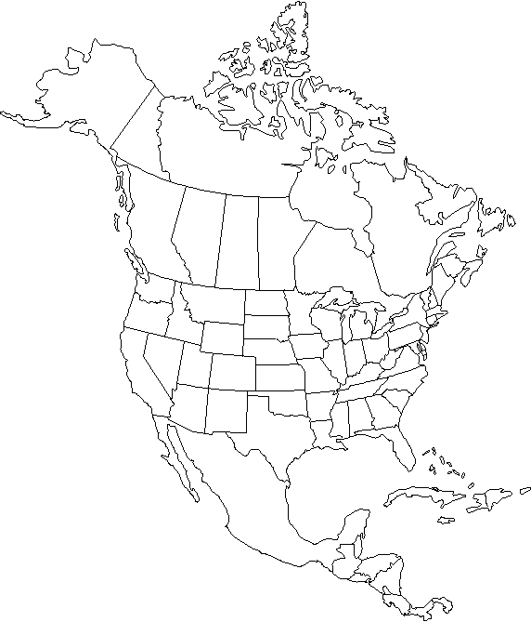
Complete the table below using the image on the right.
E
D
C
B
A
Letter | Temperature  (Cold, Warm) | Humidity  (Dry, Humid) | Name of Air Mass (CT,CP,MT,MP)
A
B
C
D
E
Complete the chart about warm and cool air.
 | Warm Air | Cool Air
Which Direction Does it Move?
Does it more or less dense?
Does it have high or low pressure?
Which direction does air pressure move?
Areas of _______________ pressure move to areas of _______________ pressure.
Complete the Chart about the different type of fronts.
 | What does the warm air do? | What does the cold air do? | What type of weather does this bring?
Warm Front
Cold Front
Stationary Front
Occluded Front

- Land heats up _____________________ than water and cools off _____________ than water.
- Water heats up ____________________ than land and cools off _______________ than water.
- How does the unequal heating of land and water create local winds?
______________________________________________________________________________________
______________________________________________________________________________________
______________________________________________________________________________________

- How does the unequal heating of land and water create global winds?
______________________________________________________________________________________
______________________________________________________________________________________
______________________________________________________________________________________
 | Where does the breeze start? | Where does the breeze end? | Does it happen during the day or night? | Air above land | Air above water
Sea Breeze |  |  |  | Temperature: | Temperature:
 |  |  |  | Air Pressure: | Air Pressure:
Land Breeze |  |  |  | Temperature: | Temperature:
 |  |  |  | Air Pressure: | Air Pressure:

