Unit 2 Study Guide Key
When is your Unit two test? ___ Friday________
- Put the phases of the moon in order starting with a new moon.
New Moon Full Moon 3rd Quarter Moon Waxing Gibbous
Waning Crescent 1st Quarter Moon Waning Gibbous Waxing Crescent
1
New Moon | 2 Waxing Crescent | 3 1st Quarter | 4 Waxing Gibbous
5 Full Moon | 6 Waning Gibbous | 7 3rd Quarter | 8 Waning Crescent

- Use the following words to complete the sentences: Orbit, revolve, rotates.
  - The Earth __rotates___ on its axis.
  - The Earth ____revolves_____ around the sun and the path it takes is called is _orbit___.
  - The Moon ___revolves______ around the Earth and the path it takes is called is ___orbit____.
- Complete the sentences about the moon:
  - Waxing means that the part of the moon that you see is getting __larger___. The side of the moon that you will see when it is waxing is the ___right_______ side.
  - Waning means that the part of the moon that you see is getting __smaller_____. The side of the moon that you will see when it is waning is the ____left______ side.
  - When there is a full moon the __Earth__ is between the ___Moon___ and the __Sun___.
  - When there is a new moon the ___Moon___ is between the __Earth___ and the __Sun__.
- Why do we see phases of the moon?
___The moon reflects sunlight. As the moon revolves around the Earth we see different amounts of the sunlit side of the moon.________.

 | Drawing of Moon, Earth and Sun | Drawing of Moon, Earth and Sun | Strong or Weak?  Straight Line, or 90° | What phases of the moon does it occur?
Spring Tide | E | E | Strong Tides  Straight Lines | New Moon  Full Moon
Neap Tide | E | E | Weak Tides  90° | 1st Quarter  3rd Quarter
 | Drawing of Moon, Earth and Sun | Why does it occur? | What phases of the moon does it occur?
Solar Eclipse | E | The moons shadow falls on the Earth. Your view of the sun is blocked. | New Moon
Lunar Eclipse | E | The Earth’s shadow falls on the Moon. You can no longer see the moon because it has no sunlight to reflect. | Full Moon

- What causes seasons?
__The tilt of the Earth causes different parts of the Earth to receive different amounts of indirect and direct light.
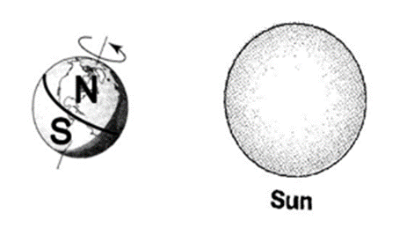
- What season is the Northern Hemisphere experiencing and why?
The Northern Hemisphere is experiencing summer because it is tilted toward the sun and is receiving more direct light. ____________________________________________________
What season is the Southern Hemisphere experiencing and why?
_The Southern Hemisphere is experiencing winter because it is tilted away from the sun and is receiving more indirect light.____ ____________________________________________________

- When the Earth rotates one time we have experienced a ___day______.
- When the Earth revolves one time we have experienced a ___year_____.
- Tell me everything you know about what is going on, or could be going on, when the moon is in position A.
____Full moon, lunar eclipse or a spring tide

- Tell me everything you know about what is going on, or could be going on, when the moon is in position D.
___Spring Tide, New Moon, Solar Eclipse____________________________________________________
- Tell me everything you know about what is going on, or could be going on, when the moon is in position B.
______1st Quarter Moon, Neap Tide__________________________________________________________
- Tell me everything you know about what is going on, or could be going on, when the moon is in position C.
_____Waxing Crescent Moon Phase__________________________________________________

