Name: ______________________________________ Period _________
Weather Fronts Key
- An air mass is a large body of air with similar ____temperature___.
___humidity______, and ___air pressure_____.
- Air masses take on the properties of the areas that they __form over__.
  - If they form over the ocean, they are ___moist__ and we call these
____maritime____.
  - If they form over land, they are ___dry_ and we call these
____continental___.
  - If they form over polar latitudes, they are __cold___ and we call
these __polar___.
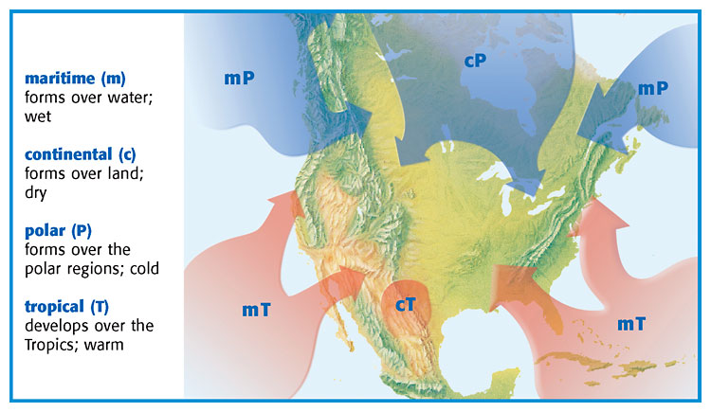
  - If they form over tropics, they are ___warm____ and we call
these ____tropical_____.
- A front is the _boundary_ between two _airmasses___.
- Fronts are classified by the kind of airmass that is moving in to replace the other type of air
  - If a warm air mass is coming in to replace a cold air mass that is called a
__warm front_____.
  - If a cold air mass is coming in to replace a warm air mass that is called a
______cold front_______.
Type of front | Diagram (with arrows to show movement) | What is happening with the air? | What is the weather like? | Weather map symbol
Warm Front | 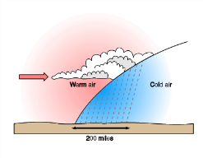 | Warm air is coming in to replace cold air | Drizzly rain and are followed by warm, clear weather
Cold Front | 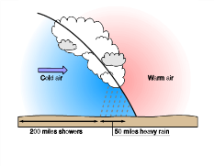 | Cold air moves under the less dense warm air | Move quickly, bring thunderstorms, heavy rain or snow and cool weather
Stationary front | 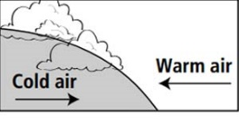 | Cold air mass meets a warm air mass but neither have enough force to move the other out of the way. | Several days of cloudy, wet weather in one place | 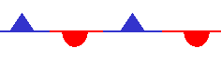
Occluded Front | 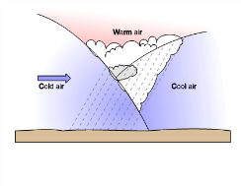 | Forms when a warm air mass is caught between two colder air masses | Cool temperatures and large amounts of rain and snow

- Fronts form along areas of __low__ pressure.
- Low pressure = ____inclement____ weather.

